

Practices for Secure Software Report

Table of Contents
Document Revision History 3
Client 3
Instructions 3
Developer 4
1. Algorithm Cipher 4
2. Certificate Generation 4
3. Deploy Cipher 4
4. Secure Communications 4
5. Secondary Testing 4
6. Functional Testing 4
7. Summary 4
8. Industry Standard Best Practices 4

Document Revision History

Version | Date | Author | Comments
1.0 | 6/20/2026 | Romi’on Price

Client



Instructions

Submit this completed practices for secure software report. Replace the bracketed text with the relevant information. You must document your process for writing secure communications and refactoring code that complies with software security testing protocols.

- Respond to the steps outlined below and include your findings.
- Respond using your own words. You may also choose to include images or supporting materials. If you include them, make certain to insert them in all the relevant locations in the document.
- Refer to the Project Two Guidelines and Rubric for more detailed instructions about each section of the template.

Developer
Romi’on Price

Algorithm Cipher

A. AES -256 or Advanced Encryption Standard 256 would work the best, as it ensures data confidentiality. It’s considered the industry's gold standard due to its robust encryption. It has a key length of 256, which is 14 rounds of keys and each round consists of mixing plain text into cipher tex. Meaning 14 rounds of transformations to encrypt data. AES is reversible, meaning it can encrypt and decrypt data. This is essential for banking information, confidentiality and proper encryption ensures data integrity.

B. The Hash functions and bit levels are intended to protect data integrity, it ensures data is not altered or changed. “A cryptographic hash function takes an input (or message) of arbitrary length and returns a fixed-size string of n-bits as output” (IBM, 2015). AES uses 128-, 192-and 256-bit levels, meaning each key length is correspondent to that number. Artemis Financial is recommended to use the 256-bit level as it is standard in financial institutions. A larger key length makes it harder for brute attacks due to the complexity of the keys.

C. Random numbers make unpredictable keys, making it a secure way of protecting against attackers who try to guess encryption keys. Symmetric keys are “used to scramble information in a way that is virtually impossible to unscramble without the secret key” (Manico & Detlefsen, 2014). Meaning it uses one key to both encrypt and decrypt information. While Asymmetric keys uses two different keys. “One key, the private key, is kept secret and is known only to the sender. It is used to sign the data. The other key can be made public and can be known by anyone” (Manico & Detlefsen, 2014).

D. “The first known evidence of the use of cryptography (in some form) was found in an inscription carved around 1900 BC, in the main chamber of the tomb of the nobleman Khnumhotep II, in Egypt” (Sidhpurwala, 2023). Next was a type of substitution cipher, known as “Caesar cipher,” to convey secret messages to Julius Caesar’s army generals. The Enigma machine was invented by Arthur Scherbius and “encoded a substitution table and each key press from the keyboard resulted in the output of cipher text” (Sidhpurwala, 2023). IBM designed a cipher called “Lucifer” and was then called DES or the Data Encryption Standard. DES was overshadowed by the new block cipher AES or Advanced Encryption Standard, due to the small size of DES’ encryption key. AES is widely accepted standard used for symmetric encryption.

Certificate Generation
Insert a screenshot below of the CER file.

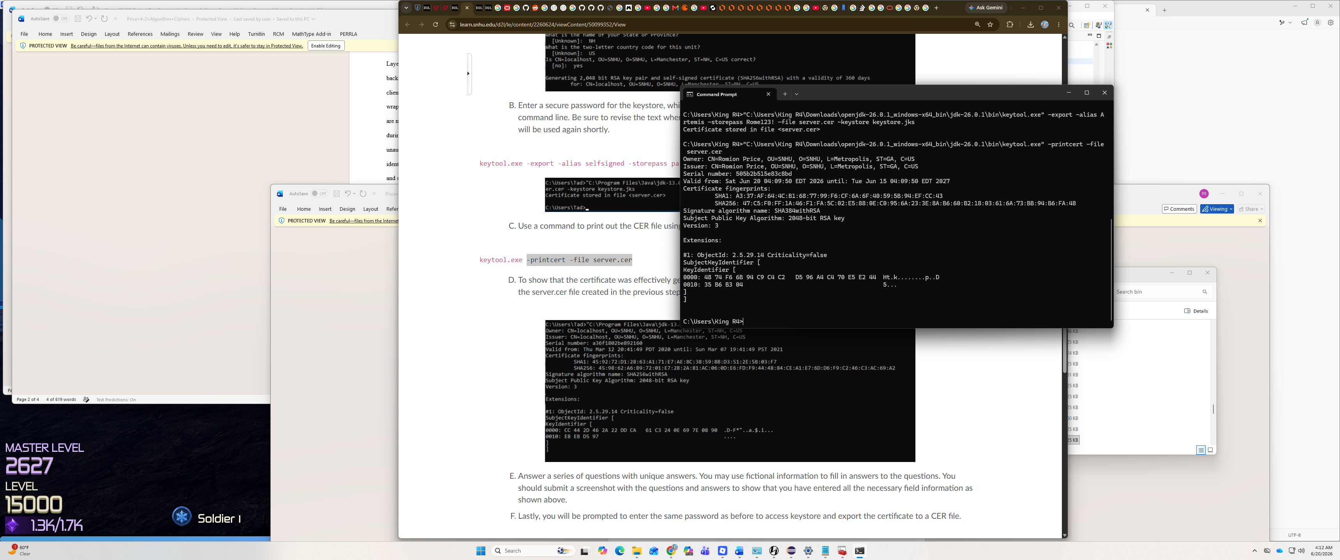

Deploy Cipher
Insert a screenshot below of the checksum verification.

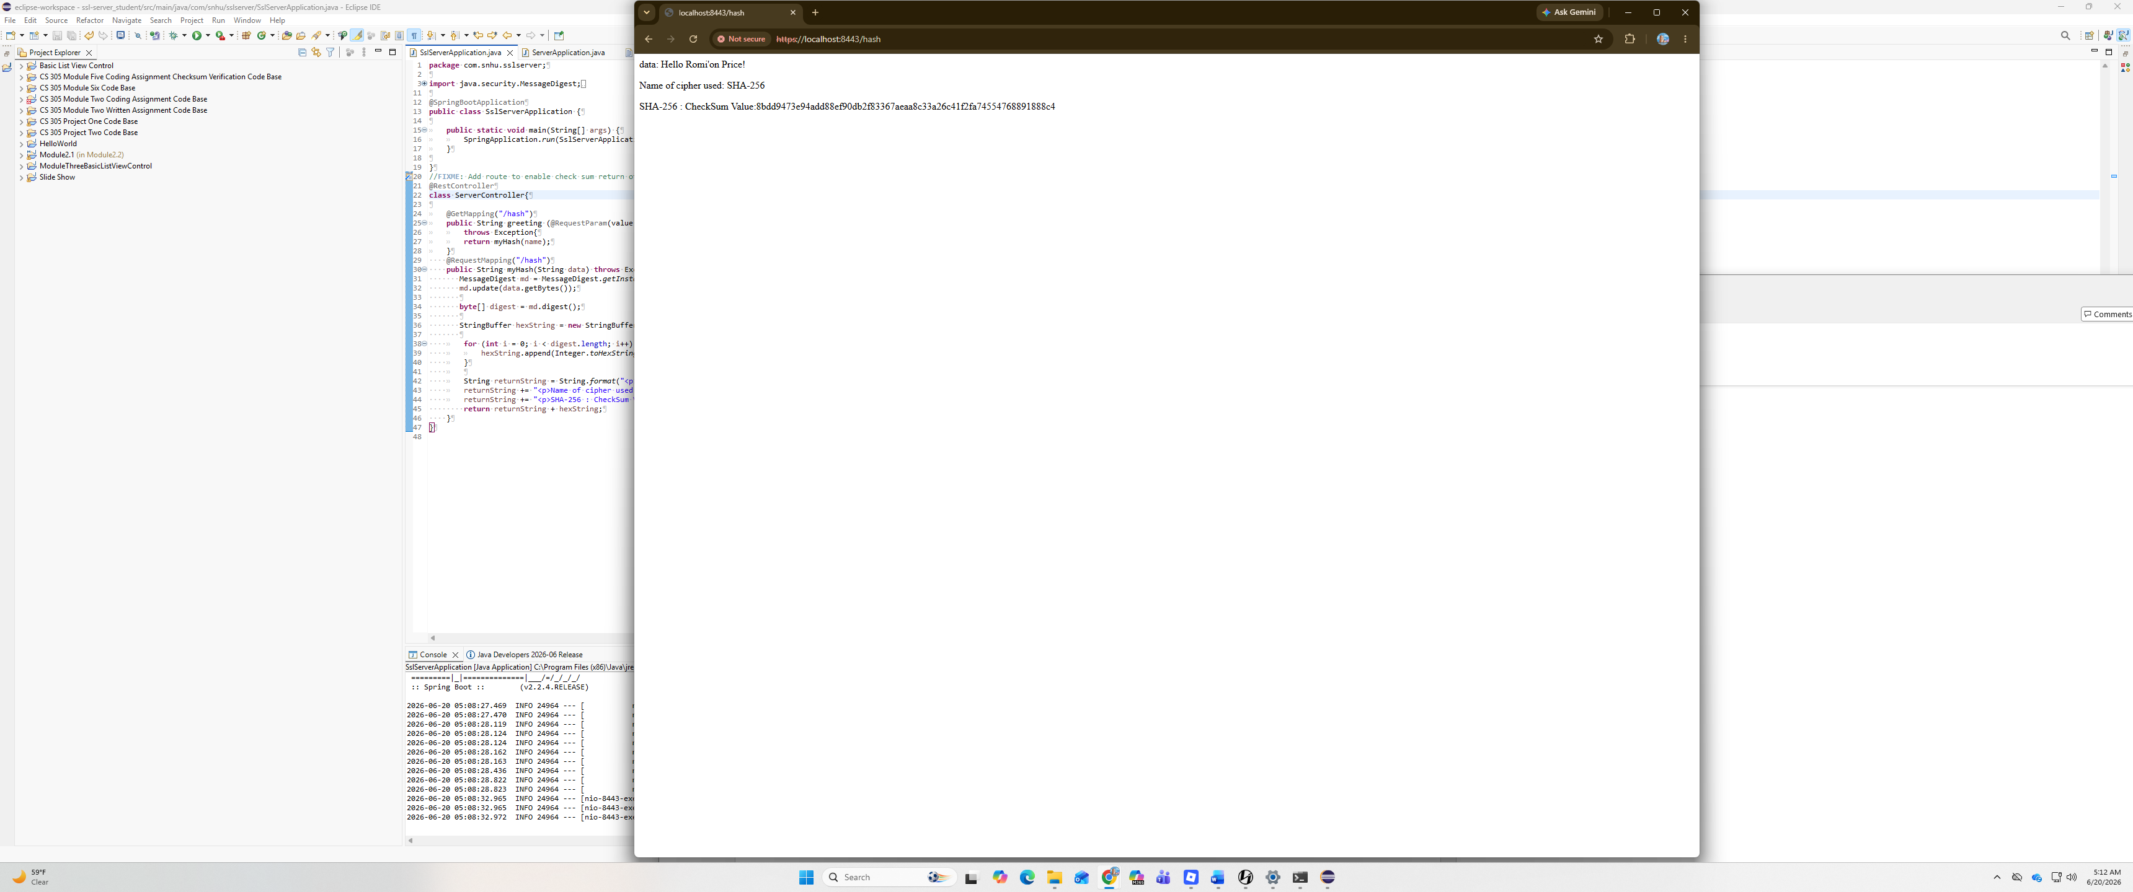

Secure Communications
Insert a screenshot below of the web browser that shows a secure webpage.


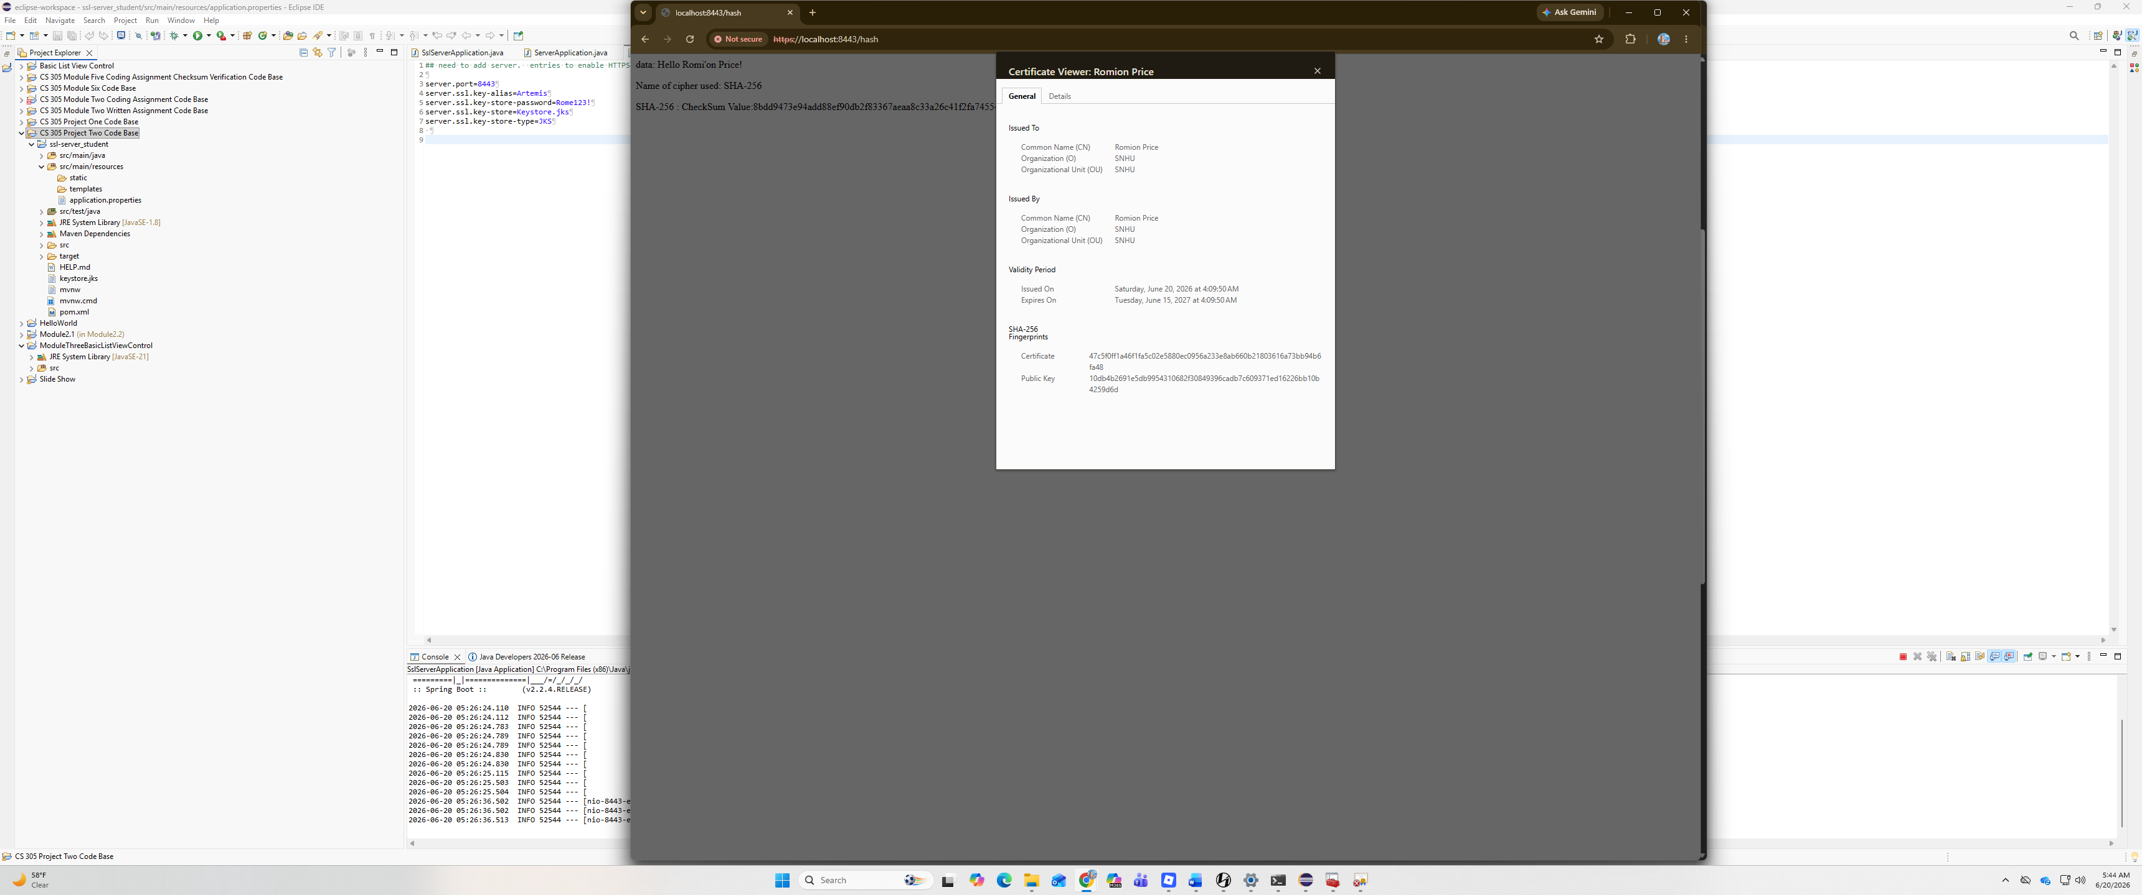

Secondary Testing

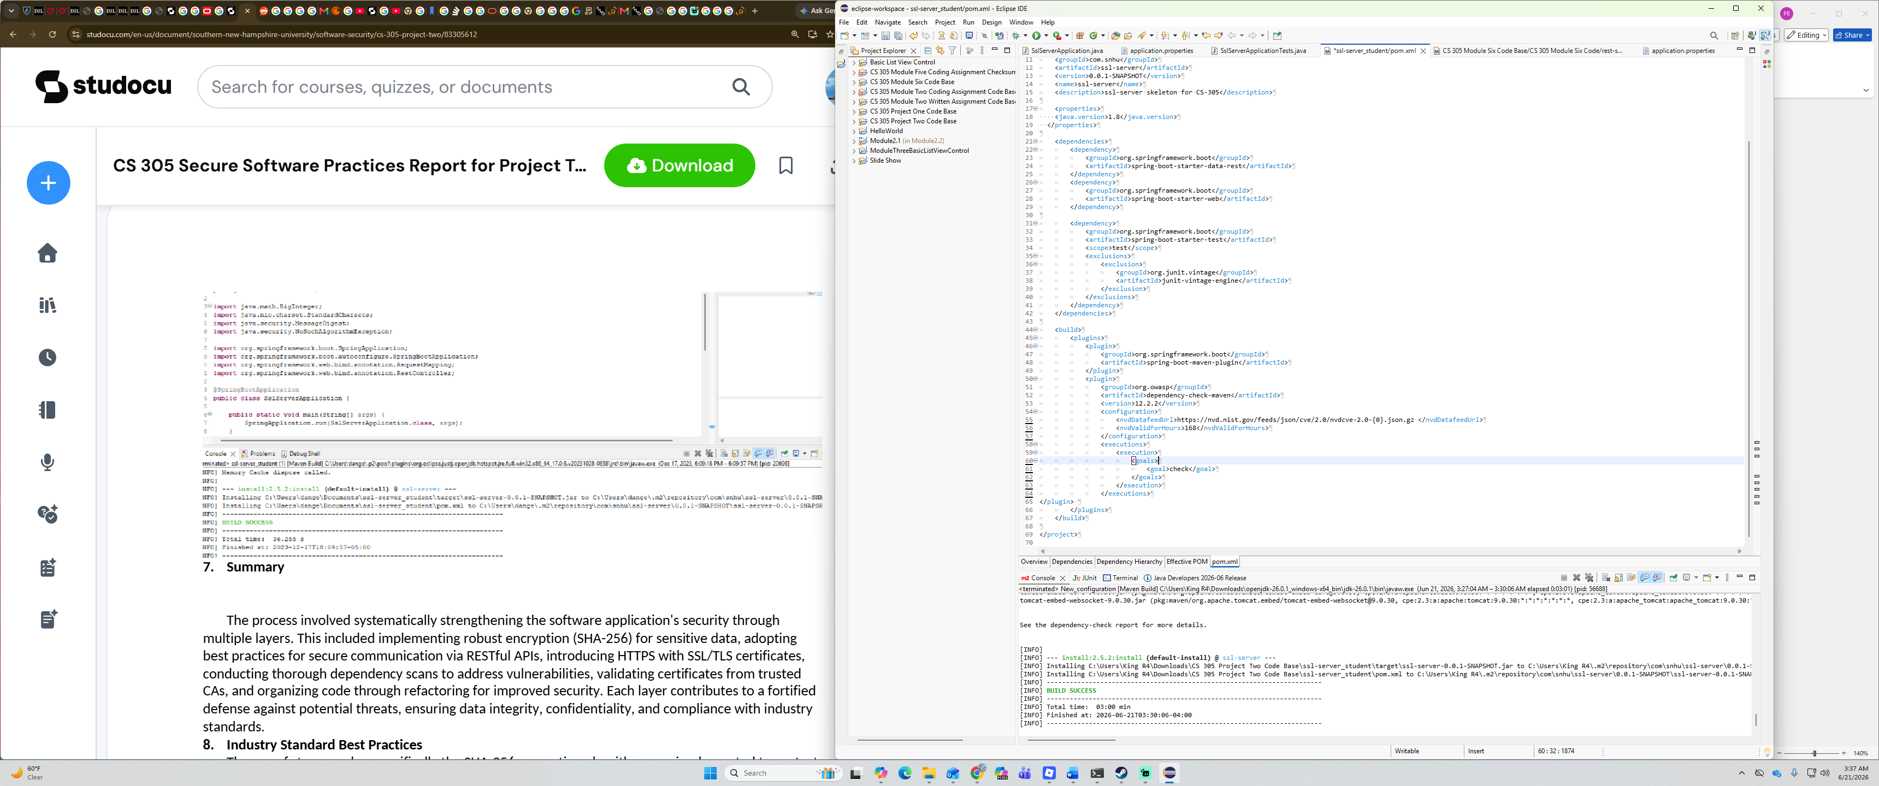

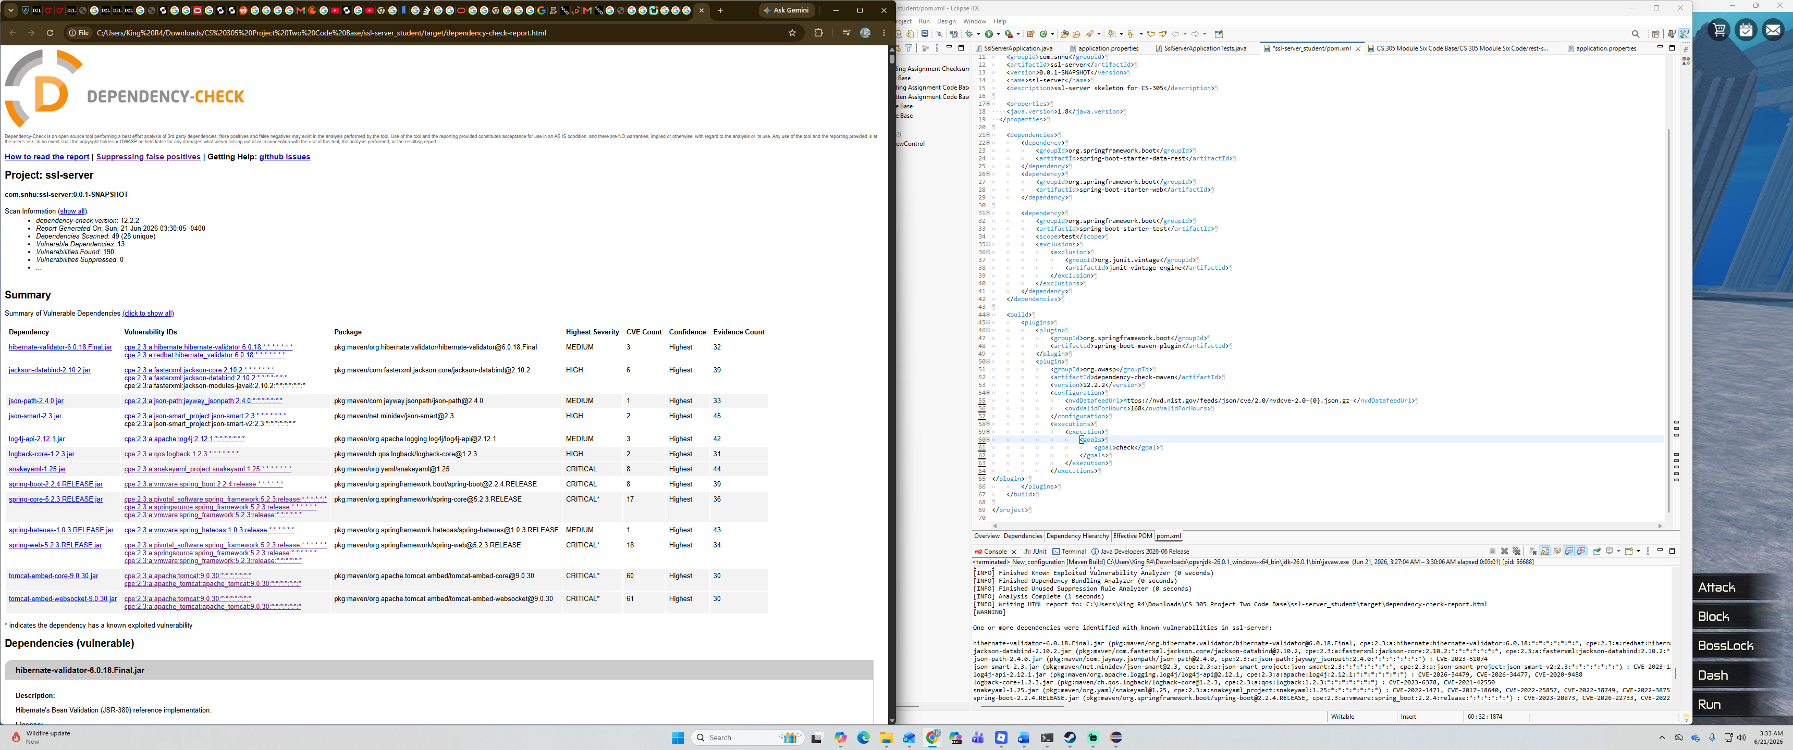

Functional Testing
Insert a screenshot below of the refactored code executed without errors.
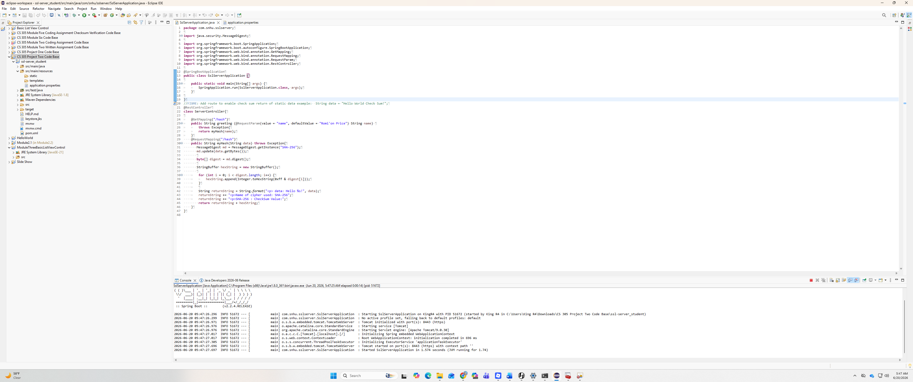

Summary

A: The code has been refactored by including a hashing function that helps in scrambling consumer data making it almost impossible to reverse it in case of a hacking attempt. Deploying the algorithm cipher SHA-256 ensures the integrity of the data. Self-signed certificates helped in enabling the usage of HTTPS, were a key security enhancement. Validating certificates from trusted CAs helped in keeping compliance with industry standards.

B: First starting off by generating a self-signed certificate. Second, deploying a cipher by implementing a hash algorithm that displays the data, name of cipher used and the cipher with the checksum value. Third, is ensuring communication is secure by converting http to https protocol by refactoring code. Fourth, running a static test with the dependency tool to look for vulnerabilities, making sure the maven version is up to date. Lastly, functional testing by ensuring that there is no errors that might introduce more vulnerabilities. Overall, enhancing the security in layers will help defend against potential threats.

Industry Standard Best Practices

A: Implementing data encryption methods such as algorithm ciphers to keep data safe against unauthorized users. Regular testing to find any new vulnerabilities. Also input validation to prevent against attack like SQL inject or XSS were essential. Secure data transmission with communication protocols like HTTPS, was another step in keeping data safe in transit.

B: Finding and patching vulnerabilities helps keep resource cost low. It also ensures customer retention and trust. Keeping certificates and everything updated helps in streamlining regulatory compliance. Ensuring the integrity of the data and code of a company gives a competitive advantage in robust security. Having regularly tested and well-maintained system is essential for a company.
References:

Cryptographic hash functions | IBM Quantum Learning. (2015). IBM Quantum Learning. https://quantum.cloud.ibm.com/learning/en/courses/quantum-safe-cryptography/cryptographic-hash-functions
‌
Manico, J., & Detlefsen, A. (2014, September). 6 Protecting Sensitive Data - Iron-Clad Java [Book]. Www.oreilly.com. https://learning.oreilly.com/library/view/iron-clad-java/9780071835886/ch06.html#ch06lev2sec11

Sidhpurwala, H. (2023, January 12). A Brief History of Cryptography. Www.redhat.com. https://www.redhat.com/en/blog/brief-history-cryptography

